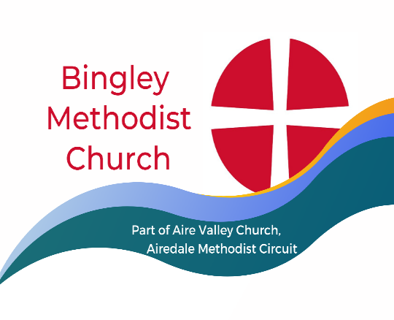
Minister Rev. Nel Shallow. Tel.01274 568163
Nel.shallow@airedalemethodists.org
Sunday 7 April 2024
Service led by Mr Michael Webster

You are very welcome at our church today. We sincerely hope you receive a blessing from this service. If you would like a visit from our Minister, or if our Church Stewards can help in any way, please let us know. Please join us for coffee afterwards.

Thought for the Week- Let everything that has breath praise the Lord.

There will be a coffee morning with a ‘bring and buy’ and a cake stall at Bingley United Reformed Church in aid of Martin House Children’s Hospice on Saturday 13th April from 10-00 until 12-00 noon. No entry fee. Donations welcome.

Walk and Lunch
We will meet at church on Saturday 20 April, leave at 11-00am and walk to the Airedale Heifer, where a table has been booked for 1-00pm The walk is leisurely and mostly on the canal bank so if people would like to join us at different stages of the walk, they are welcome to do so. Alternatively, you are welcome to just join us for lunch if you don’t want to walk. There is an option to return to Bingley by bus, as there is a convenient stop nearby.
If you would like to come, please tell Bryn as I’m away. Alternatively, contact me (details at the bottom of the page). Everyone is most welcome and I won’t need final numbers until next week. Lindsey B

Sunday 14 April
Service led by Rev. Nel
Steward/ VH Lindsey B and Shirley
Door Maureen and Bob
Coffee Rosalie and Pat
Flowers Maureen

Today
Steward/VH Lindsay S and David V
Door Pat and Amy
Coffee Lindsay S and Jean V
Flowers Mike

Items for the next notices to Lindsey Butler by Thursday please: linzibee103@gmail.com 07712 285456

