You are very welcome at our church today. We sincerely hope you receive a blessing from this service. Please stay for coffee afterwards. If you would like a visit from our Minister, or if our Church Stewards can help in any way, please let us know.

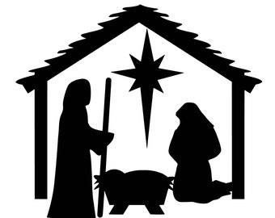
Bingley Methodist Church
Part of the Aire Valley Church
Minister: Rev. Terry Keen. Tel. 568163
Sunday 19 December 2021. Carol Service led by the Worship Leaders

Christmas Cards the charity this year is Action for Children in lieu of the cost of multiple cards. There is a donations box in the dining room if you would like to contribute.
Christmas Services- There will be a service here on Christmas Day, led by Rev. Terry Keen. On Sunday 26th December Most of the chapels will not be meeting for worship on Sunday 26th December, including Bingley. The staff team have prepared a pre-recorded service, which they hope to show on the Circuit Facebook page at 11a.m. (Airedale Methodist Circuit Facebook). It will be also be available to watch via the circuit’s YouTube channel (Airedale Methodist Circuit YouTube).
Flute Concert A big thank you to all who took part in making this event a lovely afternoon/ evening. Thank you to those who were able to come to the concert, thank you to all those who contributed cakes and thank you to those who served the food and washed up. £186 was raised for the church funds.
Winter Warmth Appeal Very many thanks to all who generously donated the lovely warm clothing and hot water bottles help the ‘street community’ in Keighley. I will pass them on tomorrow. -Lindsey B
Free Church Choir Festival will take place in Litchfield Cathedral in May. Please see poster in the entrance.
Notices to Lindsey Butler please- linzibee103@gmail.com 07712 285456
Today
Sunday 19 December
Carol Service led by our Worship Leaders
Stewards David Stocks and Sue Atherton
Music Ian Horsman
Door Gill Neasham and Carol Lake
Flowers Joyce Dykes
Coffee Pam Downs and Val Pearson

Sunday 2 January
Service led by our Worship Leaders
Stewards Lindsey Butler and David Varley
Music Ian Horsman
Door Shirley Dixon and Mike Scargill
Flowers Shirley Dixon
Coffee Katherine Watson and Rachel Slater

